Name: Md. Arif
Batch: SQA-5
Assignment 3: Git installation And Commit

Download Git according to OS:
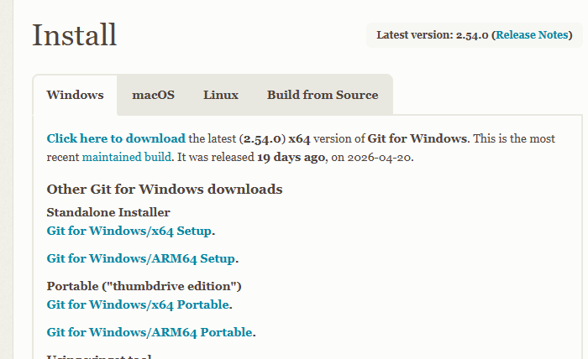

Install the Git Local device: Double click and Run as administrator
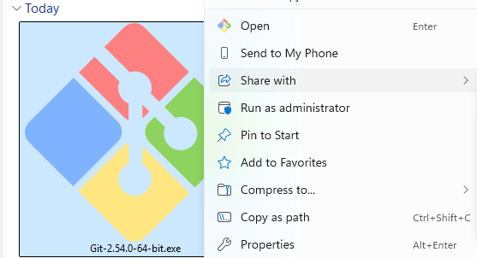

Version check from terminal using command:
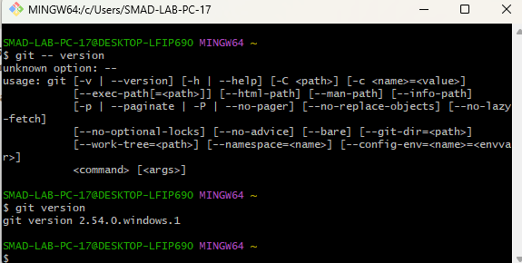

Log In Git Hub Account using Valid Credentials
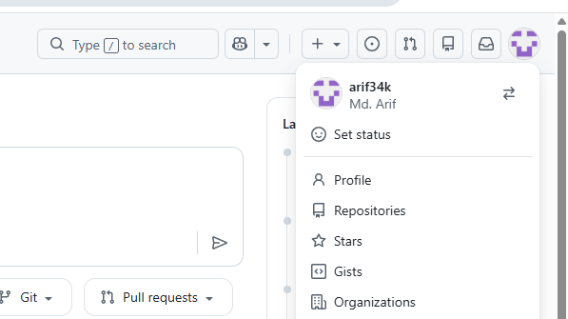

Create a repo. The repo name is “Edge-software-testing.”
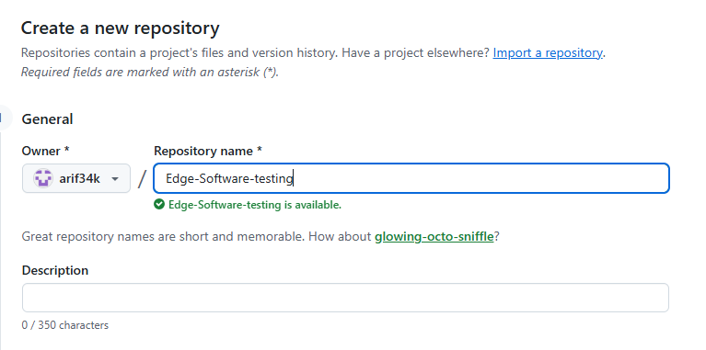
Clone the Git to local device:
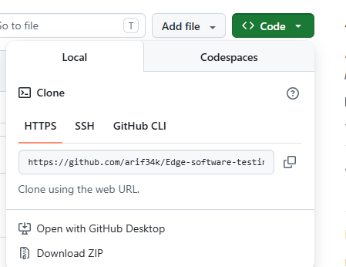

Clone Done Successfully
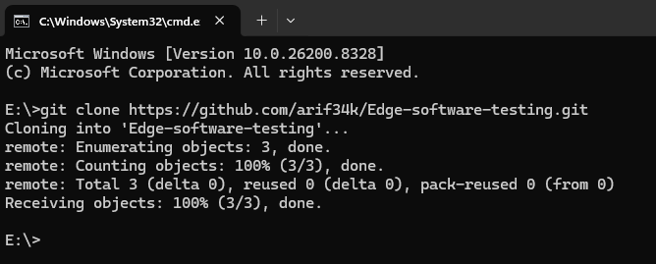

Push Git to origin and Authentication set up:
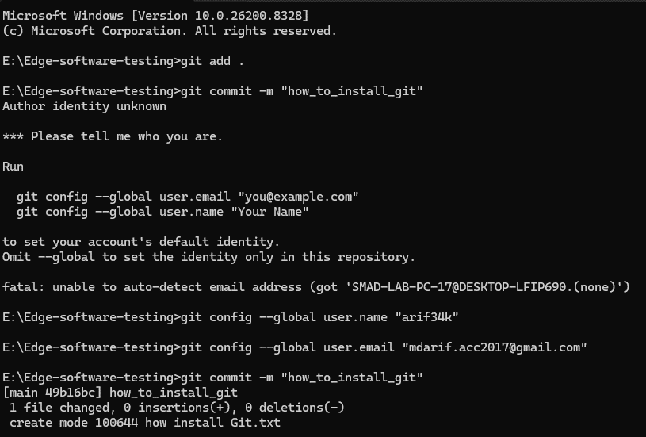
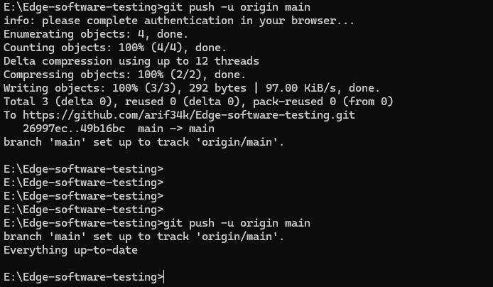

Successfully push to Github origin:
